EXAM QUESTION & ANSWERS

Q.1. Create a domain named **Gold.local** and Join the Windows client to the domain you created. Verify if you can login from the client using a non- admin domain user. Also install **Additional Domain Controller (ADC)**

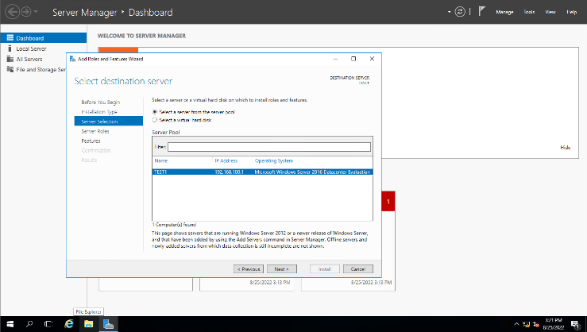**Ans;- Step 1 -- Select destination server**

Step 2 :- Deploying Configuration  
 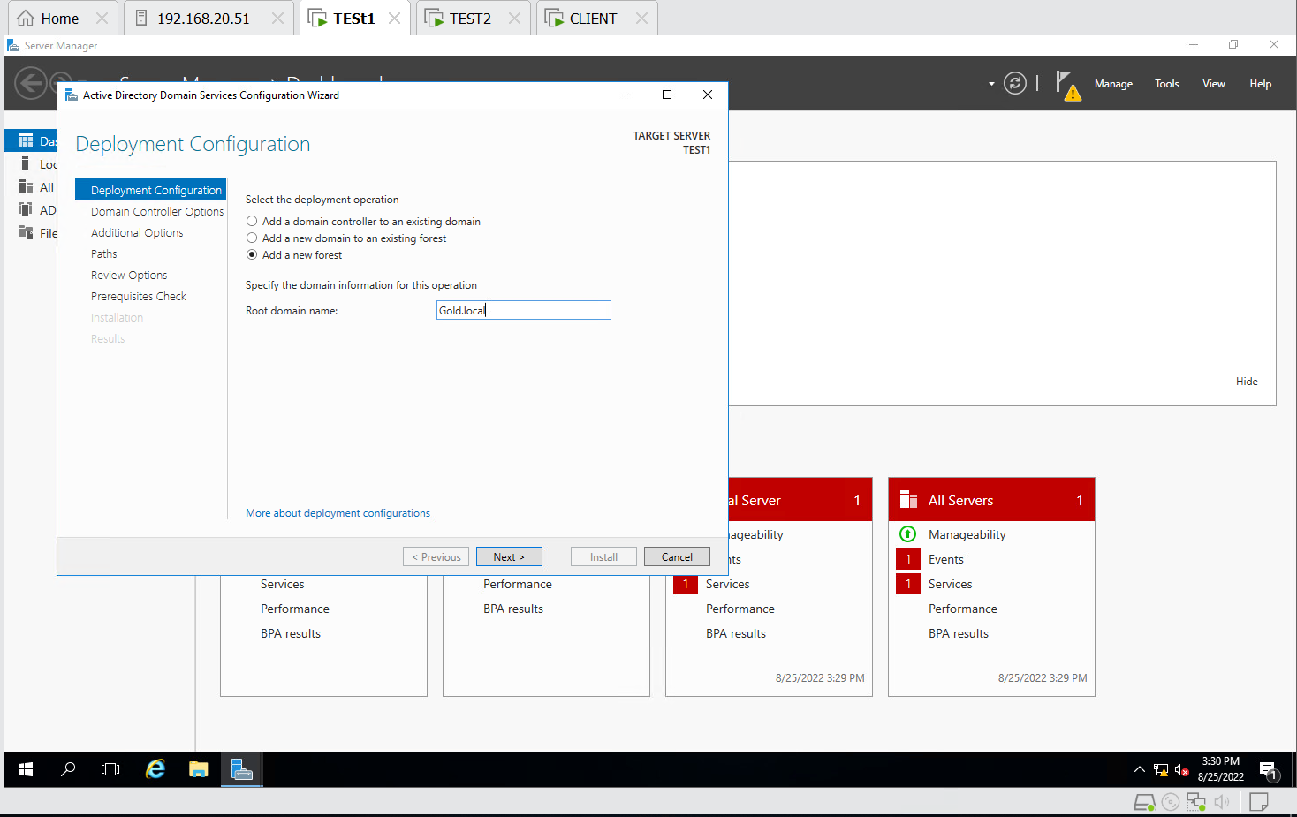

Step 3 :- Active directory domain services  
 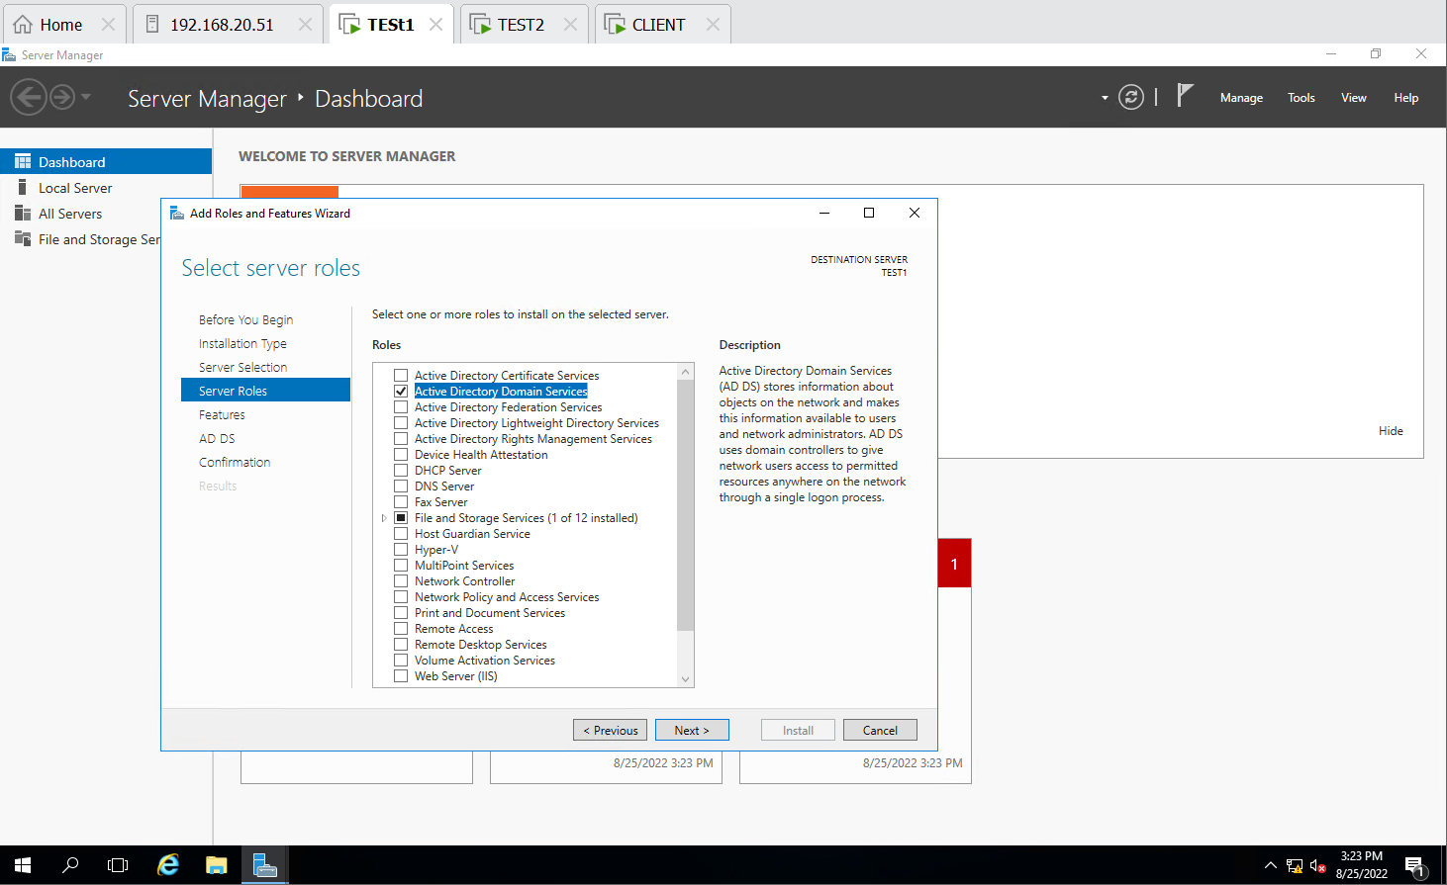

Step 4 :- All the Steps done in Test 1 & Test 2

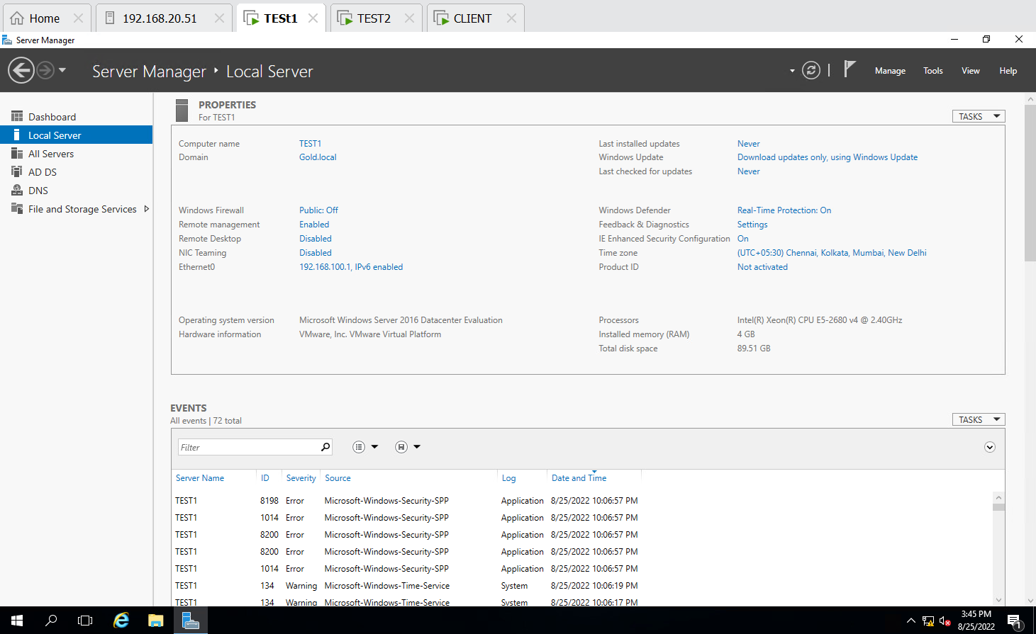 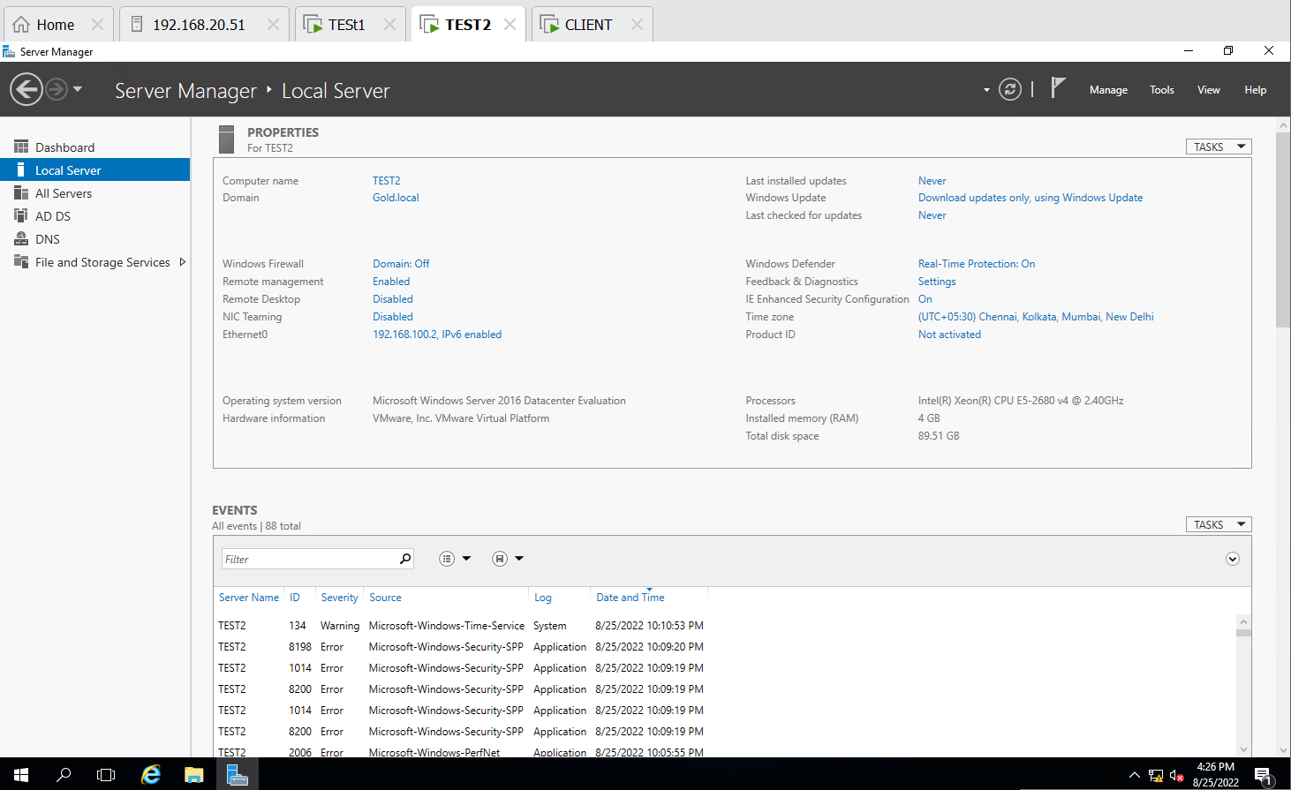

Step 5:- Successfully connected Client with Test 1

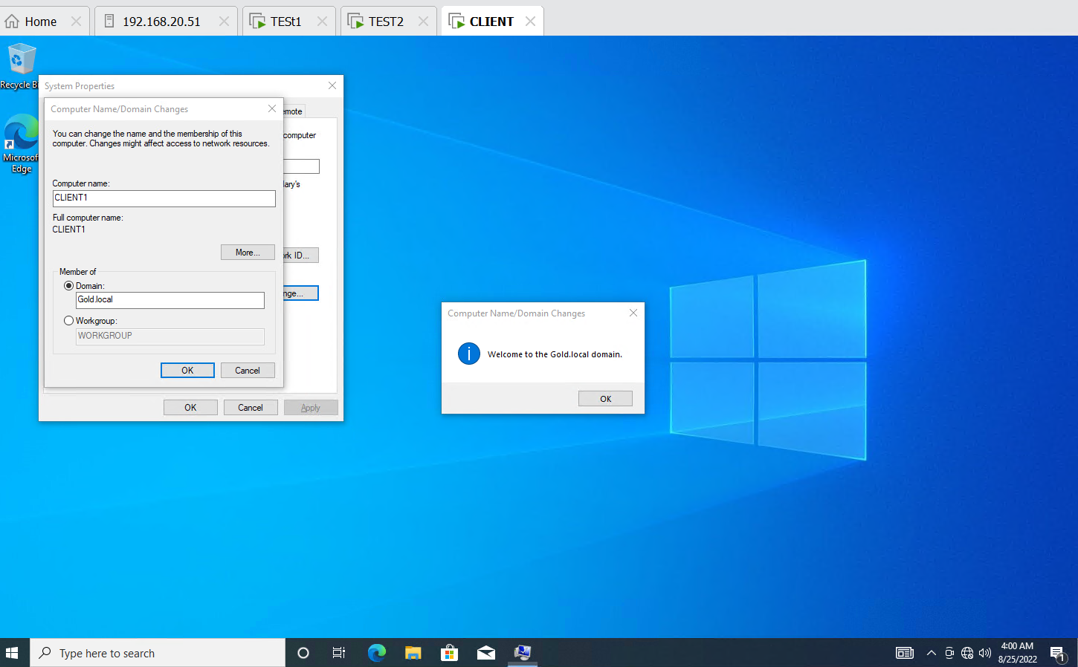

Step 6 :- Successfully login from the client using a non- admin domain user.

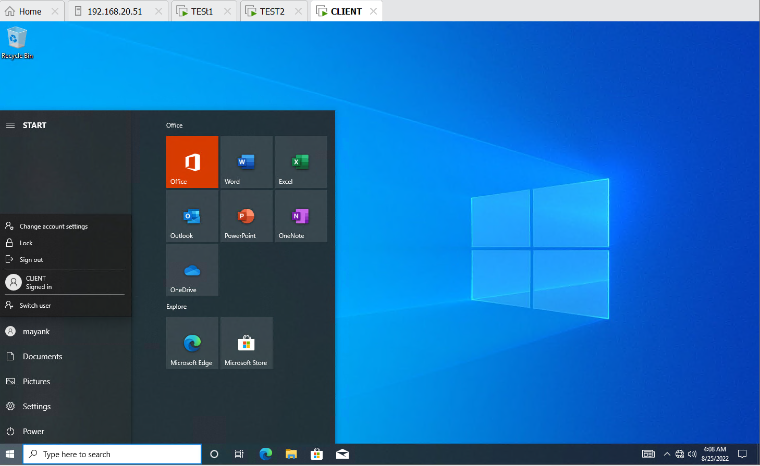

Q.2. Perform all tasks related to DNS including all types of DNS records creation, Create Forward Lookup Zone, Create Reverse lookup zone. Display the current DNS Cache, Clear the current DNS Cache. Verify if all records are getting resolved from the Client OS.

Step 1 :- Created Forward lookup zone and reverse lookup zone and then checked its working or not in client Cmd with writing both name and address.

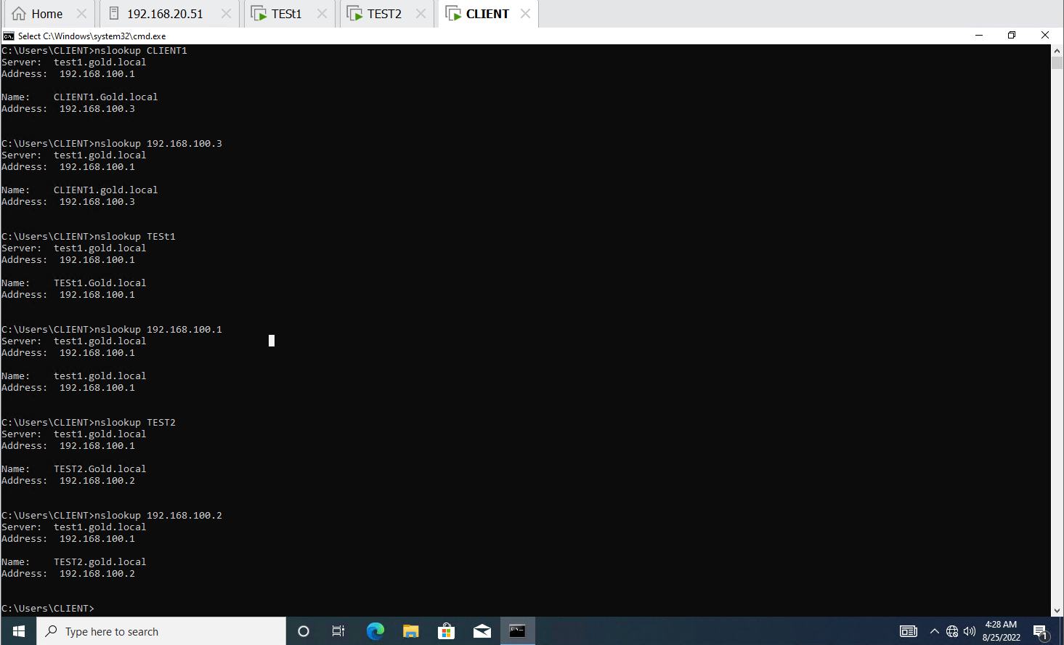

Step2 :- Display the Current Dns Cache

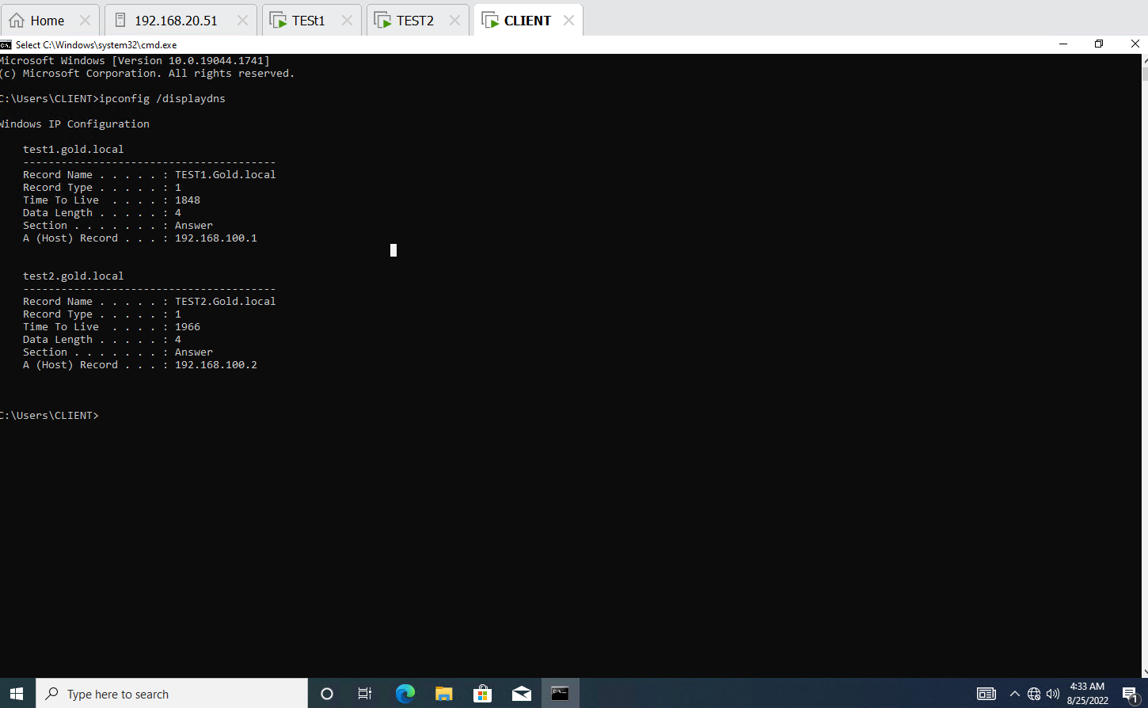

Step 3 :- Clear the current Dns Cache 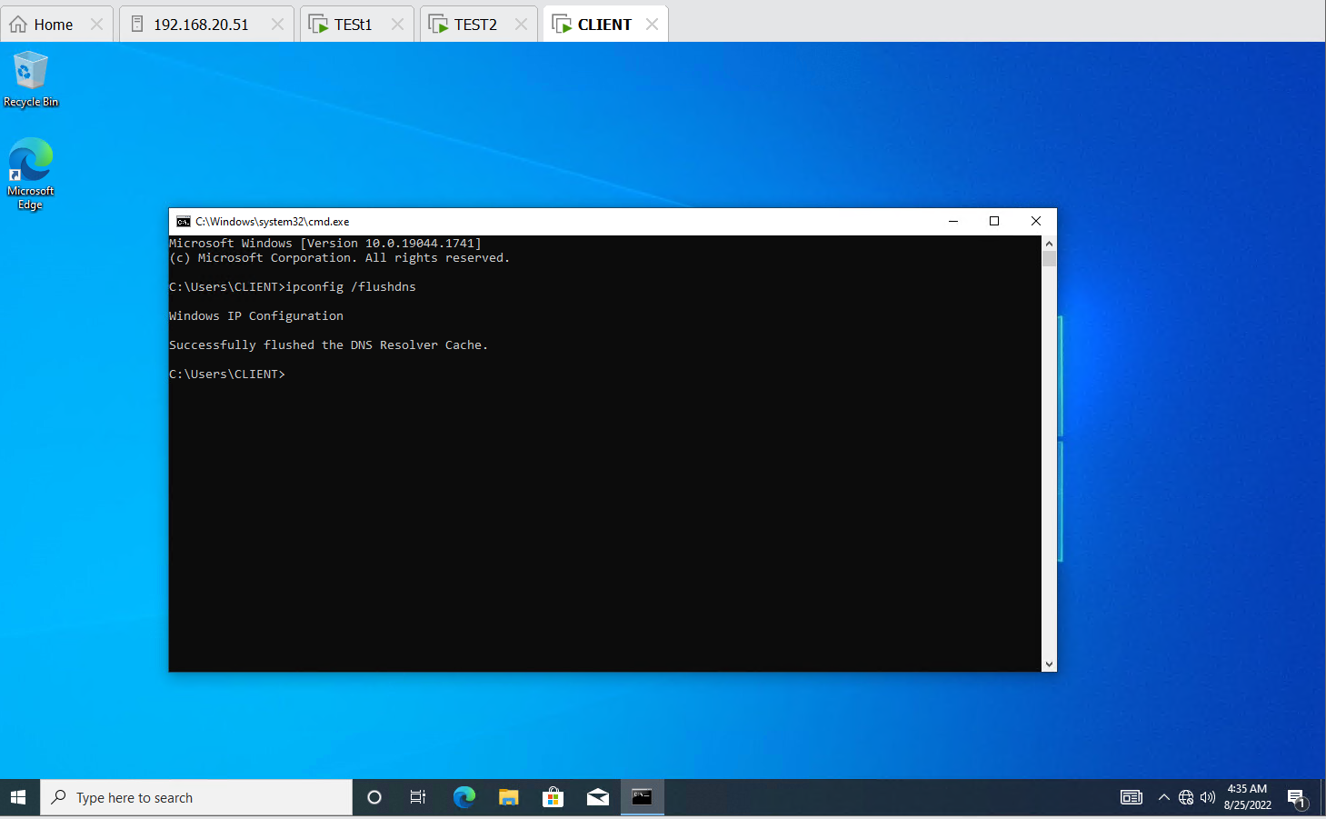

Q.3. Clients should get dynamic IP address every 5 hours. Scope 192.168.100.100 to 192.168.100.200 and exclude starting and Ending IP address

Step1. After installing the DHCP server Set the Range of IP address from 192.168.100.100 to 192.168.100.20

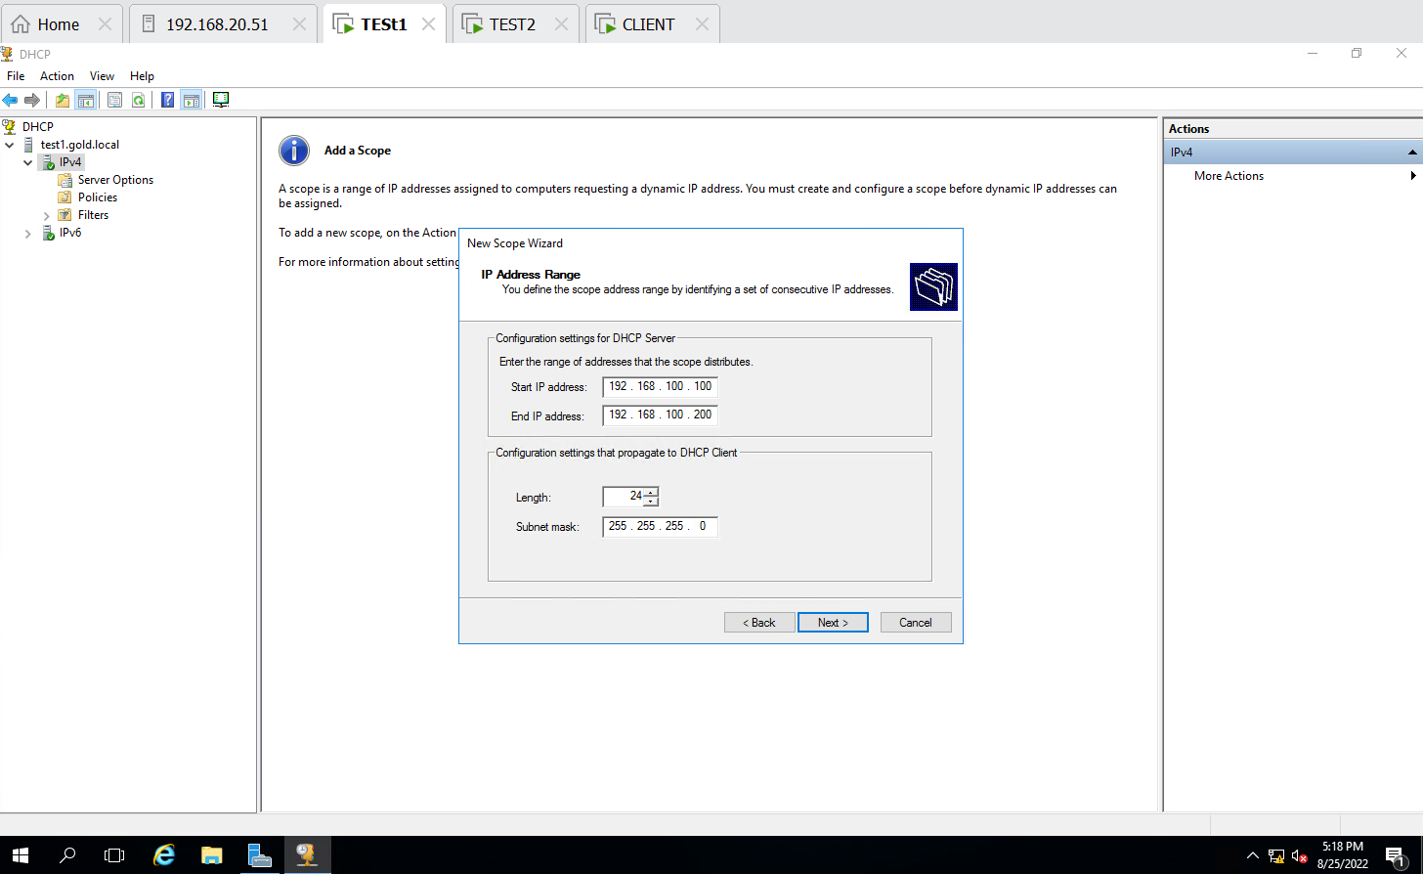

Step2 :- excluded starting and Ending IP address

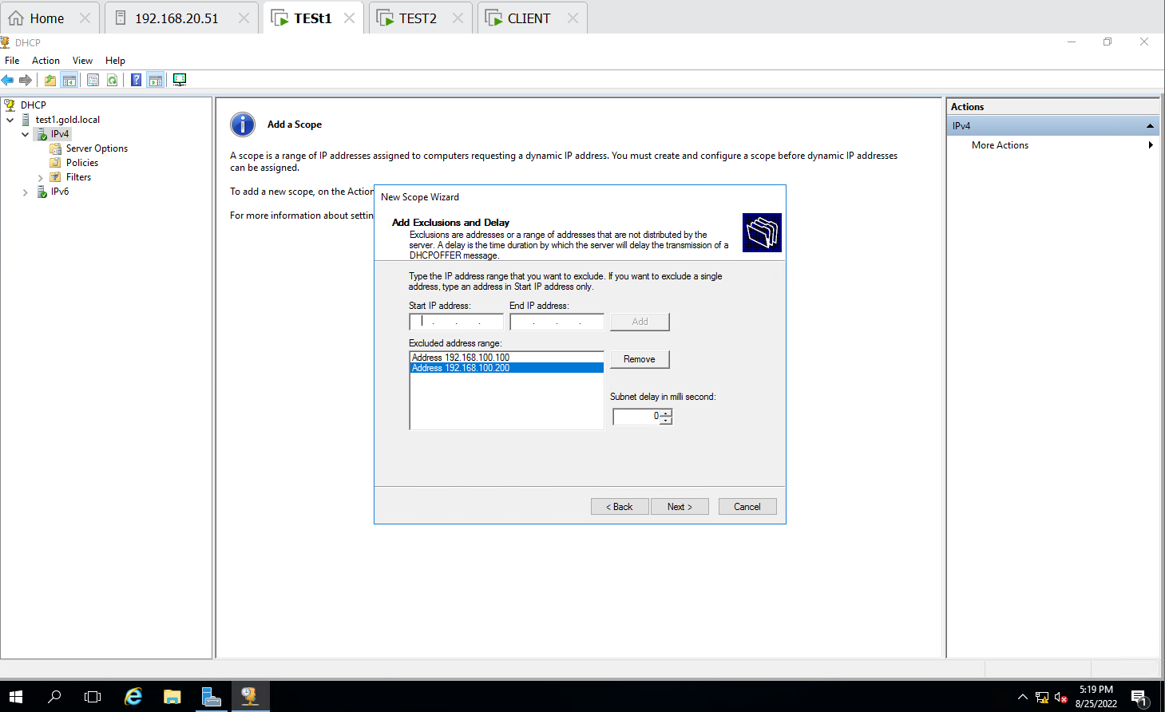

Step 3 :- Clients will get dynamic IP address every 5 hours

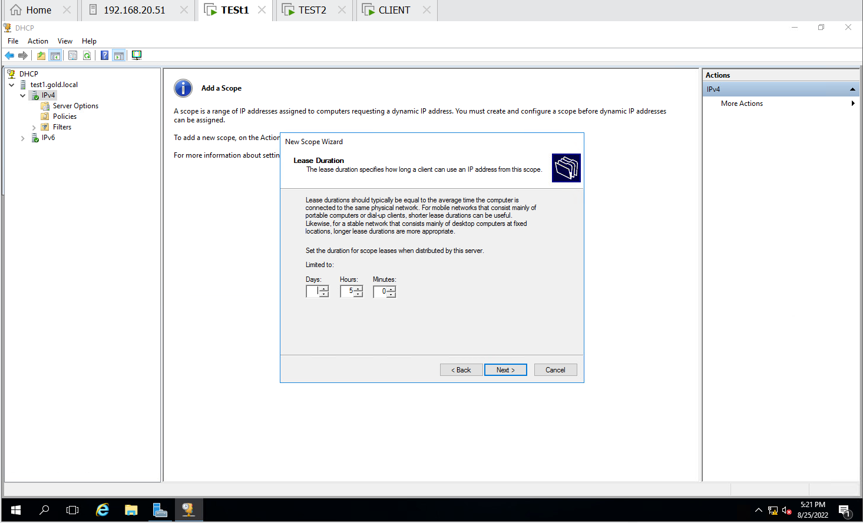

Step 4 :- Automatically IP address is been assigned to the client.

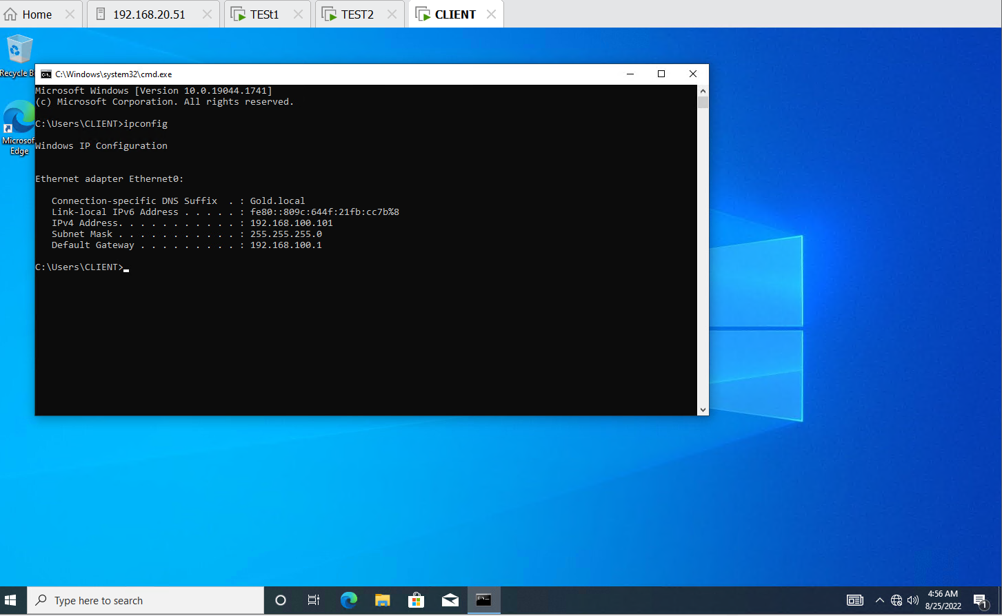

Q.4. Create below mentioned OU’s and users, groups. Group members are from own OU.

|  |  |  |
| --- | --- | --- |
| Organizational Unit | Users | Group Name |
| IT | Adam, Siri | ITgroup |
| Sales | Aditya, Amanda | Salesgroup |
| HR | Kin, den | HRgroup |
|  |  |  |
|  |  |  |

STEP 1 – Created User, groups and OU

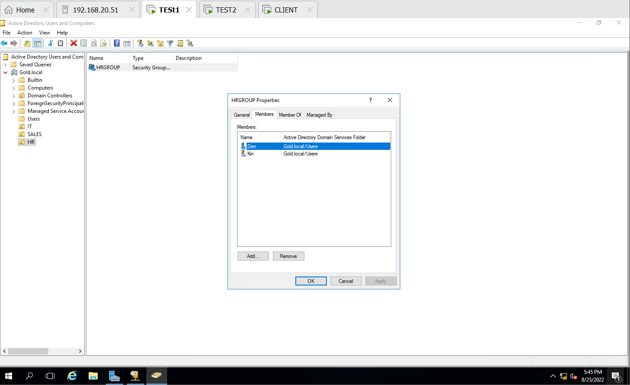

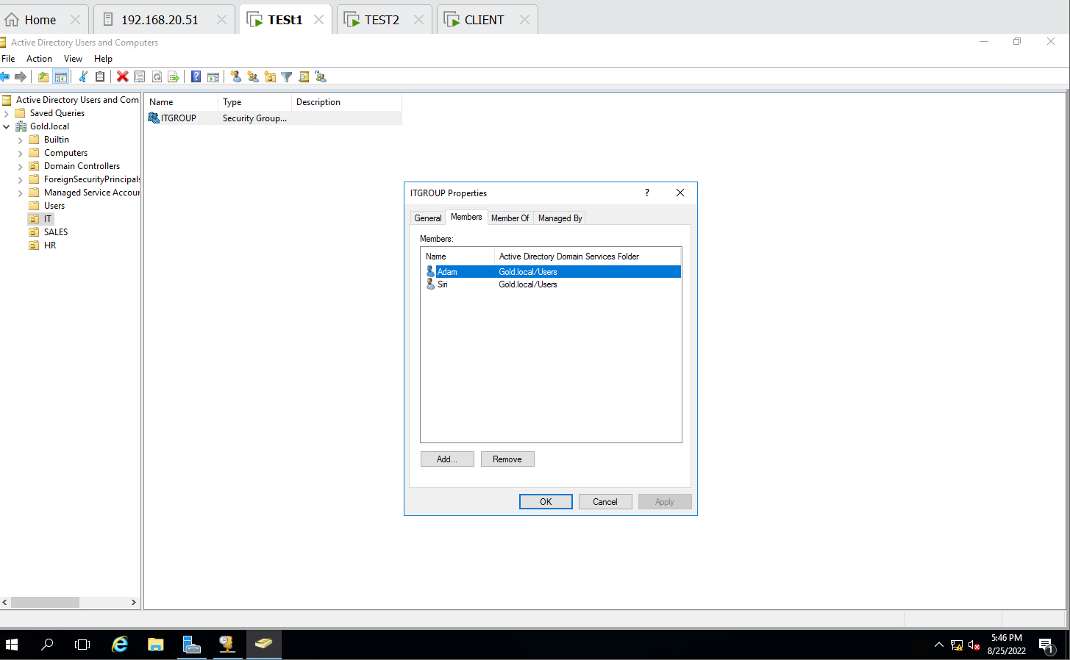

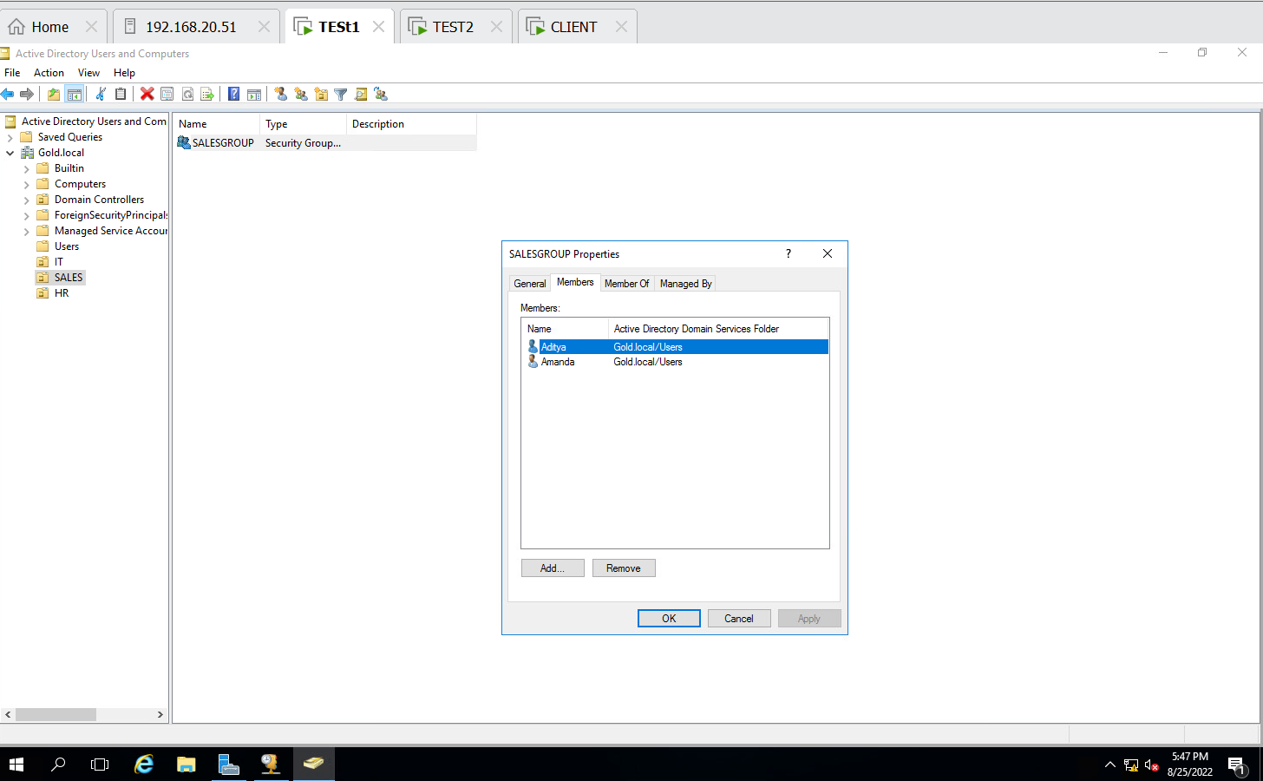

Step 2 :- LOGIN Adam from IT in Client machine

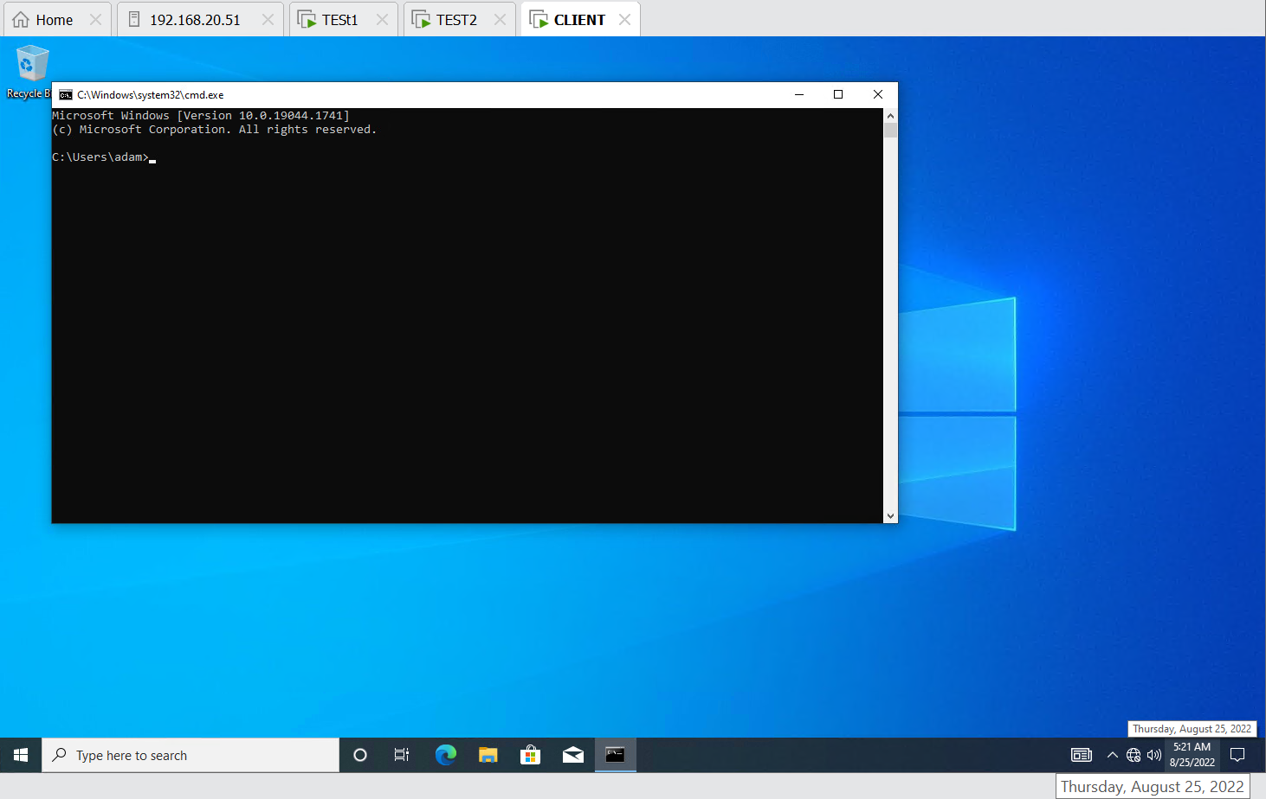

Step 3:- LOGIN amanda from sales in Client machine

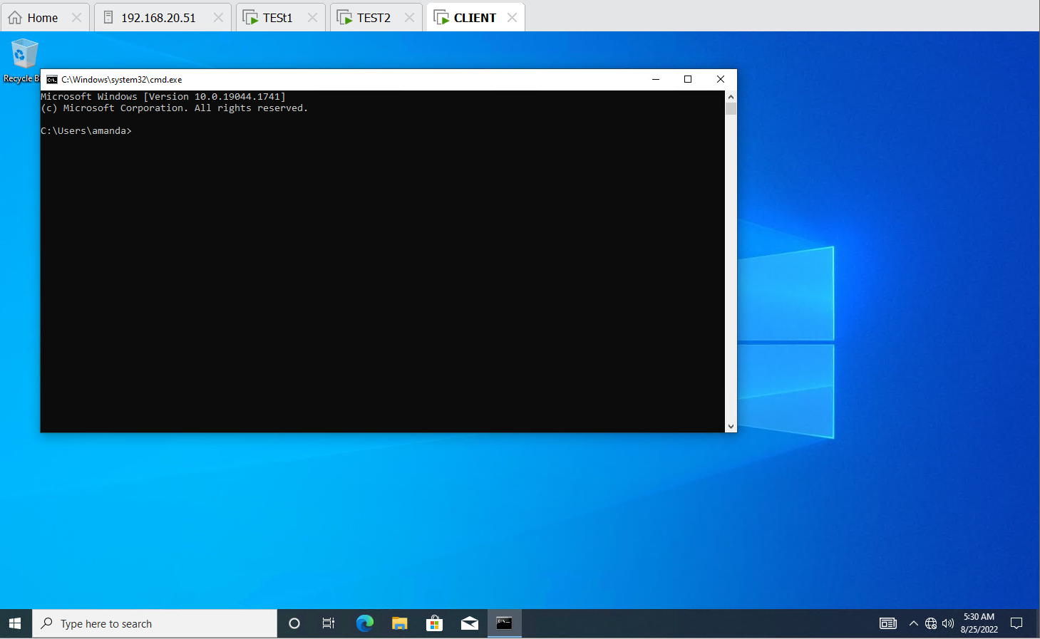

Step 4:- LOGIN kin from HR in Client machine